**Software Project(NETFLIX)**

**1.Project analysis**

**Introduction**

The purpose of this document is to specify the functional and non-functional requirements for the Netflix streaming platform. The document outlines the features that the platform should have, the constraints it must operate under, and the technical specifications that it should adhere to.

**Scope**

The Netflix platform is a video streaming service that provides subscribers with access to a wide variety of movies and TV shows. The platform is available on multiple devices, including desktop computers, laptops, mobile phones, tablets, and smart TVs. The scope of this document includes the software requirements for the platform's web and mobile applications.

**Functional Requirements**

1.User Account Management

- The platform allows users to create a new account with their email address or social media accounts such as Facebook or Google.

2.Content Catalog Management

- The platform provides a catalog of movies and TV shows available for streaming.

3. Video Streaming and Playback

- The platform allows users to stream movies and TV shows in high quality.

4. Recommendations

- The platform provides personalized recommendations for movies and TV shows based on user viewing history, ratings, and watchlist.

Non-functional Requirements

1. Performance

- The platform is able to handle a high volume of simultaneous streams without degrading video quality or causing buffering.

2. Security

- The platform uses encryption to protect user account information and payment details.

3. Availability

- The platform is available 24/7 to subscribers, except during scheduled maintenance periods.

**Conclusion**

This Software Requirements Specification document outlines the functional and non-functional requirements for the Netflix streaming platform. The platform's features include user account management, content catalog management, video streaming and playback, and recommendations. The non-functional requirements include performance, security, and availability.

2-Use Case Diagram

3.User Flow Diagram

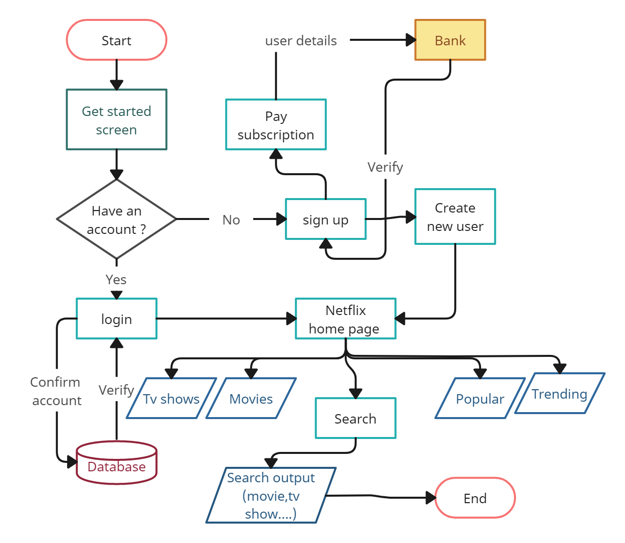

4.Entity Relationship Diagram

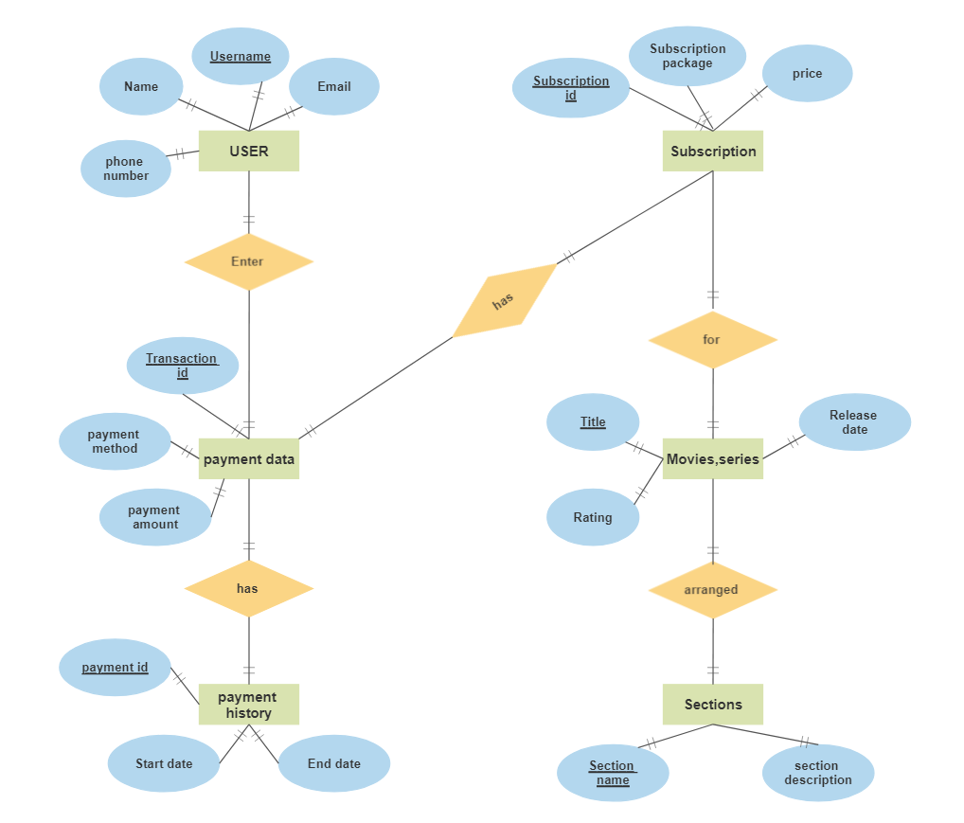

5.Test cases

